You are going to create squares for your vocabulary the squares look like this:
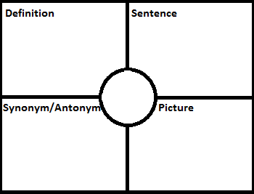
Each square should be at least half a notebook page in your interactive notebook. Please complete a square for each of the following words:
- Archaeology- is the study of past people and cultures through a careful examination of artifacts
- Artifacts-an object made by a person for a purpose
- Prehistoric-a period of time before written records
- Paleo- the first people who entered and inhabited the Americas during the final ice age
- Nomads-people who travel from place to place to find food
- Ice Age-severe cold periods where glaciars covered the earth.
- Big Game Hunters-people who hunt big animals for food
- Big Game- animals that existed in the ice age; mammoth, saber tooth tiger, mastodon, ect.
- Stone Age- a prehistoric period in which stone was widely used to make tools
- Adapt- adjust or change to suit conditions

